Steps for Hello World application

- Start BRMS:

The IT user needs to start the BRMS after configuring it.
- IT user….
- Xx

- Login to BRMS:

The Business user logs on to the BRMS upon starting the BUI. The BRMS server should be up, and running prior to that.

- User sends a GET request with un/password encoded in HTTP Authorization header to LoginServlet (LoginDestination on BE).
- BE creates an event (LoginEvent) using the REST serializer which has been configured for this destination through designer.
- This event is asserted to Working memory through explicit invocation of assertEvent().
- This fires a rule VerifyCredentialsRule.
- This invokes the custom catalog function “login” which is inside LoginHelper class.
- This function (Java code) calls the AuthenticationLoginModule.
- This loginModule then authenticates un/password with (default to LDAP for now).*
- Server maintains the authenticationtoken(contains info about user, and his/her roles) in session **.
- Create LoginSuccessEvent and set this concept as payload for this event.
- Call sendEvent() function inside the VerifyCredentialsRule.
- This goes to the default destination (LoginDestination), and serializes the event to XML.
- This then calls sendMessage() and passes the XiNode of the generated XML (This is the token to be sent).
- The message is then made part of HTTPServletResponse, which can be queried on the BUI using getInputStream on the Connection.

* We can authenticate with LDAP (implementation as of now), or load users/roles database into cache.
** We can either authenticate per request, in which case no session is required, or maintain state so that login is only once.
State can be maintained in 2 ways:
a.) Use Tomcat’s session, and store the token inside it so when the next time the cookie(token) arrives, the token inside this session can be matched.
b.) Create an AuthenticationTokenConcept instance, which gets asserted into WM upon successful authentication the first time. For subsequent requests, the token string sent along with the request will be matched with cached tokens (concept instances) using a sessionToken string attribute.

See the following diagram for details:
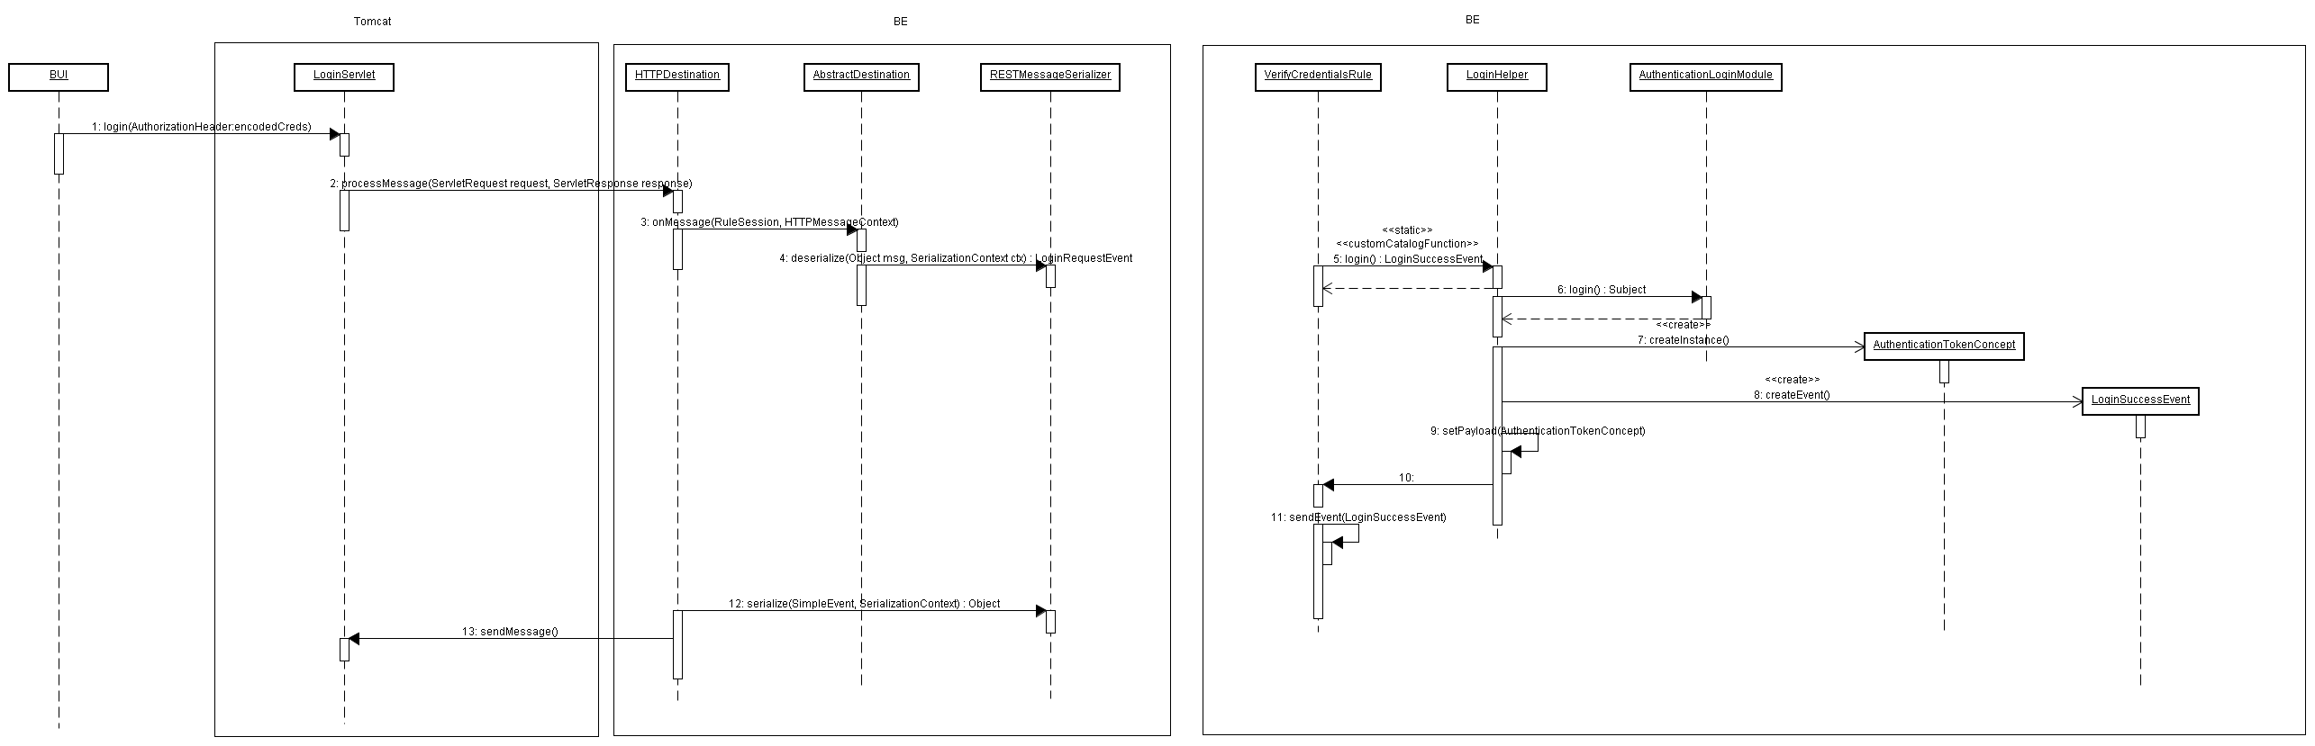

- Check Out Project:

Pre-requisites:
An Access Control policy file (ACL.xml), and a domain model file (DomainModel.dm) for this ontology are stored in the storage area (Coherence, DB etc.) using out of band mechanisms which are out of scope of BRMS.

After successful login, the Business User can checkout a decision project to work offline. The steps are as follows:
- Business User sends a GET request to the DecisionProjectServlet (Destination).
- The servlet extract the cookie/token (received upon successful authentication) sent along with the request.
- The token is verified cached tokens (either server session, or cached concept).
- The HTTP Destination creates an instance of CheckoutDecisionProjectRequestEvent.
- It asserts this event to WM.
- This triggers the rule “CheckoutDecisionProjectRule”.
- This calls custom catalog function “createDecisionProject” inside DecisionProjectHelper class.
- This gets instance of appropriate storage helper (default tangosol), and fetches the ACL.xml file from storage.
- Similarly the DomainModel.dm file is also accessed from storage.
- The input to the custom catalog function is the CheckoutDecisionProjectRequestEvent. Using the ontology, the ACL file, and DomainModel files, custom catalog jars and all virtual rulefunctions (they could have been implemented through DecisionTables)
- Create a zip archive of all these artifacts, and set them in CheckoutDecisionProjectResponseEvent event’s property.
- The CheckoutDecisionProjectRule then calls reply on this event.
- The event, and its payload is serialized by the Destination, and sent as servlet response to the BUI.
- The BUI deserializes this to the DecisionProject model (from the incoming byte stream), applies ACL to show resources with appropriate permissions and creates a local storage for this decision project (a Designer-like structure) for user to work offline *.

* There are 2 options for sending ACLs:

a.) Send the ACL policy file (should we only send fragment of ACL for roles which user belongs to, or the entire one?), encrypt it on the client-side (confidentiality protection), and dump it locally. This would also require the authentication token which was sent upon login to be stored locally, and digitally signed for integrity protection.
When the user loads a decision project from local storage, the ACL file will be decrypted, and the in memory representation will be loaded to check resource permissions against.

b.) Send the applied ACLs (list of permissions for various BE resources, e.g: Concept properties, Functions etc. embedded inside hidden Attributes of these resources.)
e.g:
<Concept name=”Person”>
<propertyDefinitions>
<propertyDefinition name=”designation”>
<hiddenAttributes>
<permissions>
<permission>766e745535</permission> -- (Number Indicates read permission)
<permission>4313256316</permission> -- (Number Indicates write permission)
</permissions>
</hiddenAttributes>
</propertyDefinition>
</propertyDefinitions>
</Concept>
The embedded numbers indicate the permissions that the role has for this resource.

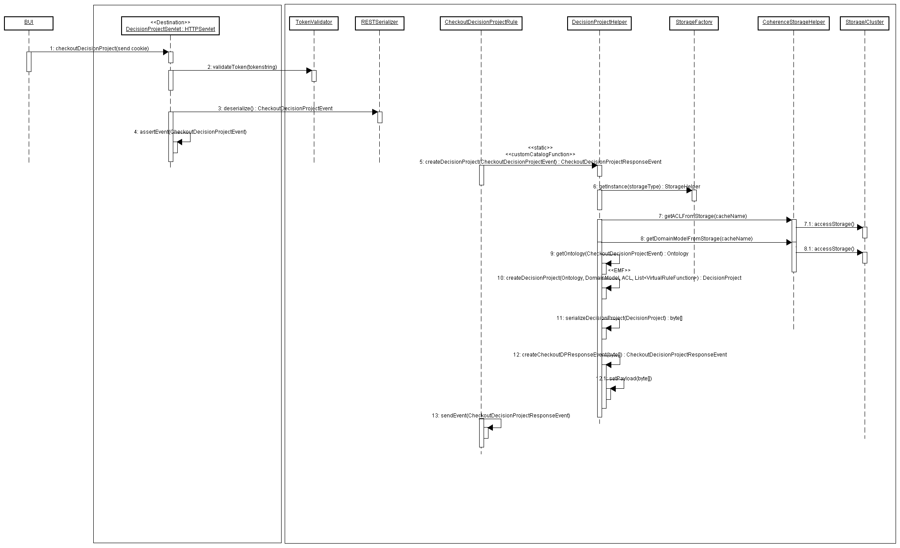

- Checkin Decision Project:

Business User after implementing Decision Tables for virtual Rule Functions/Rule Templates will send the decision project to BRMS for approval (Checkin). Steps are as follows:

- BUI sends a POST request to the DecisionProjectServlet (different context root, hence different destination than one for checkout), with cookie/token in header (or username/password for auth), with the Decision project containing (only changed?) virtual rule functions, and their implementations. We’ll use version numbers to keep track of changed files.
- BRMS deserializes this post data and creates CheckinDecisionProjectRequestEvent with the post data as payload.
- This event is asserted to WM.
- This fires a rule “CheckinProjectRule”, which invokes custom catalog function from “RequestIDGenerator” class.
- This returns a unique request id.
- The id property of CheckinDecisionProjectRequestEvent is set to this value. (This will be required for TODO lists) inside the rule.
- The CheckinProjectRule will create a DecisionProjectConcept instance with its id set to the request id generated above, and status = pending approval.
- The Concept gets asserted to WM as soon as it is created.
- This invokes the approval state machine, as status = pending approval is the entry point to the state machine for approval.
- The checkinprojectRule will also create an event CheckinDecisionProjectResponseEvent, with its id set to the same request id.
- CheckinDecisionProjectResponseEvent is sent back to BUI…
- BUI shows checkin successful

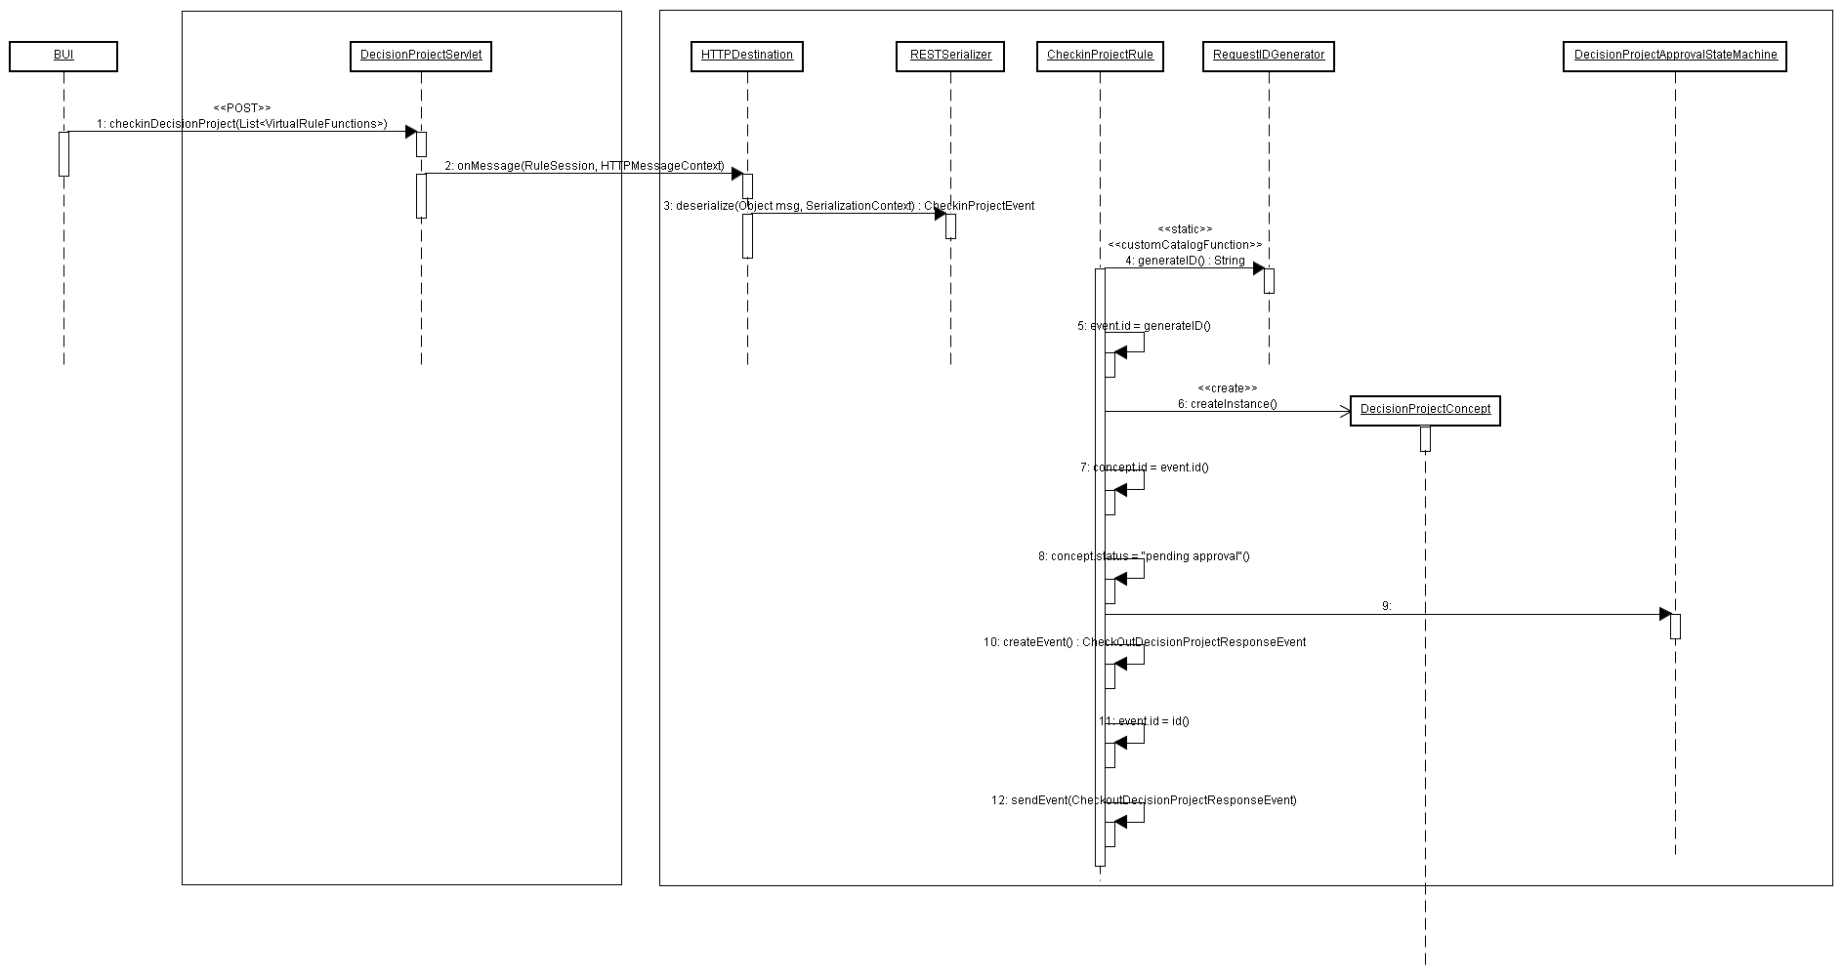
- Decision Project Status check:

- BU checks to see the status of the Decision Project they checked in.
- …

- Decision Project worklist:

- IT user logs in and sees worklist in pending approval state.
- It user accepts or rejects decision projects checked in.
- …

- Decision Project Deployment:

- Deployment IT user logs in and sees worklist of approved decision projects.
- Deployment IT user goes in and deploys it…

